# **Disaster Recovery with IBM Cloud Virtual Servers**

**Objective:**

The objective of this disaster recovery project is to establish a robust and comprehensive plan to ensure business continuity in the face of unforeseen events, such as natural disasters, cyberattacks, hardware failures, or other disruptions. The project aims to minimize downtime, protect critical data and systems, and enable a quick and efficient recovery process.

**Design Thinking Process:**

The design thinking process for this project involved:

a. Assessment of Risks and Vulnerabilities: Conducted a thorough assessment of potential risks and vulnerabilities that could impact the organization's IT infrastructure and operations.

b. Business Impact Analysis: Analyzed the critical business processes, applications, and data to identify their importance and recovery priorities.

c. Solution Design: Designed a disaster recovery strategy tailored to the organization's specific needs, considering factors like RPO (Recovery Point Objective) and RTO (Recovery Time Objective).

d. Technology Selection: Evaluated and selected appropriate technologies and tools for data backup, replication, and recovery.

e. Test and Validation: Conducted testing and validation of the disaster recovery plan to ensure its effectiveness.

**Development Phases:**

The project was divided into the following development phases:

1. Project Initiation
2. Risk Assessment and Business Impact Analysis
3. Disaster Recovery Strategy
4. Technology Selection
5. Configuration and Implementation
6. Testing and Validation
7. Training and Awareness

**Backup Configuration:**

* Scheduled backups of critical data and systems.
* Incremental and full backups to minimize data loss.
* Encryption and secure storage of backup data.

**Replication Setup:**

* Real-time or near-real-time data replication to a secondary location.
* Geographically diverse replication sites for redundancy.

**Recovery Testing Procedures:**

* Regularly scheduled recovery tests to validate the disaster recovery plan.
* Simulated disaster scenarios to assess the plan's effectiveness.

**Ensuring Business Continuity**



**Disaster Recovery Page:**

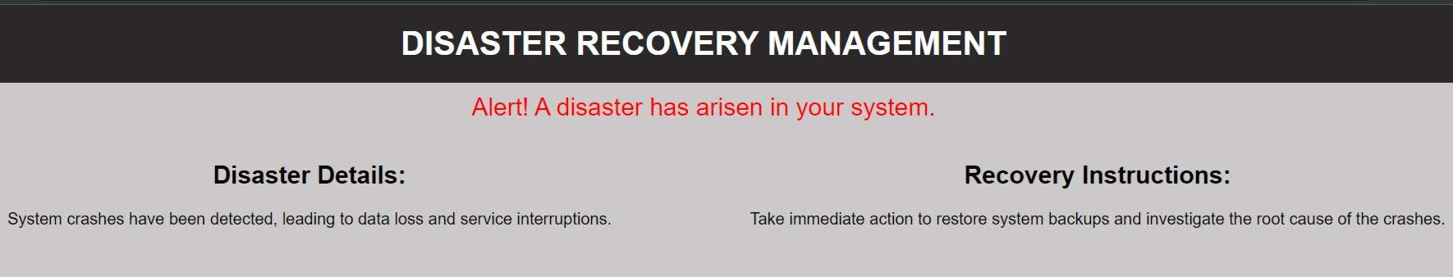



The disaster recovery plan guarantees business continuity through:

1.Minimized Downtime: The plan is designed to minimize downtime by ensuring that critical systems and data can be quickly restored.

2.Data Protection: Regular backups and replication provide data protection against loss or corruption, ensuring data integrity.

1. Redundancy: Geographically diverse replication sites and redundant systems ensure operational continuity.
2. Employee Training: Employees are trained to follow disaster recovery procedures, minimizing errors during recovery.
3. Continuous Improvement: Regular testing and evaluation allow for plan improvements, making it more effective over time.

**Conclusion:**

This disaster recovery project outlines the objectives, design thinking process, and development phases, describes the disaster recovery strategy, backup configuration, replication setup, and recovery testing procedures, and explains how the plan guarantees business continuity during unforeseen events.

1. # Set up

#

e replication to a secondary server  
**cc**

1. # Trigger automated recovery pro  
    # Ensure that the application remai